Request: This is a monthly request from Leigh Kroukamp to share data for NAM RPS bulk adjustment.
To work on this activity you will be needed bulk cycle file from previous months from respective path
EFTACB_TOT_*****-> \\omsmds001\Isd\CB&A_Programme\07 Annuities System\Reports\Bulk cycle reports
EFTACB_RPT_**** -> \\omsmds001\Isd\CB&A_Programme\07 Annuities System\Reports\Bulk cycle reports

Branch code sheet -> \\omsmds001\Isd\CB&A_Programme\Knowledge Repository\RPS\Transition\KT 2025\NAM RPS bulk adjustments\BRANCH_CODES
open EFTACB_RPS file and make sure column BANK CODE is text format and we want to remove last 2 digits (00).
select the column and use option text to column fixed width
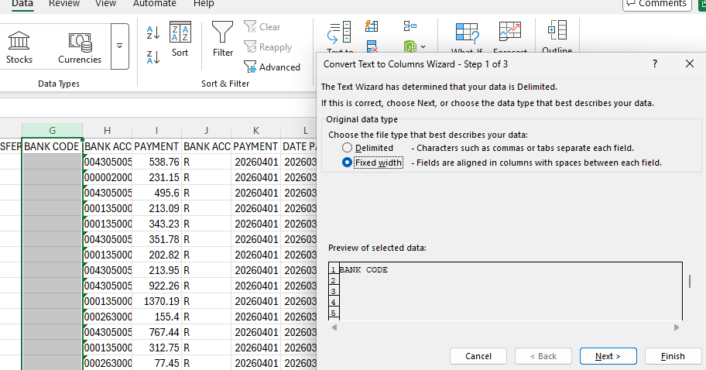
After scroll down and look for value and than select like below first field will be text and next will be do not import
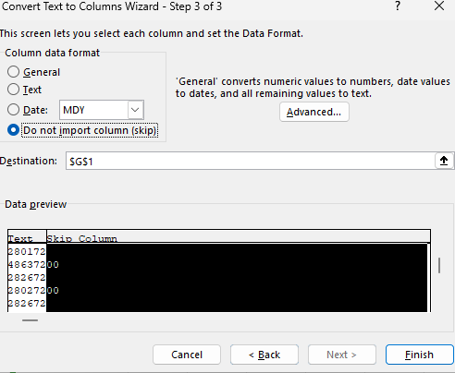

It will remove the last 2 digit.
now we will insert(Format text) a column and look bank name with there branch code.
now VLOOKUP with branch code sheet
look for first value in column G
Table Arrey will be branch code table select all column
7 column is branch name
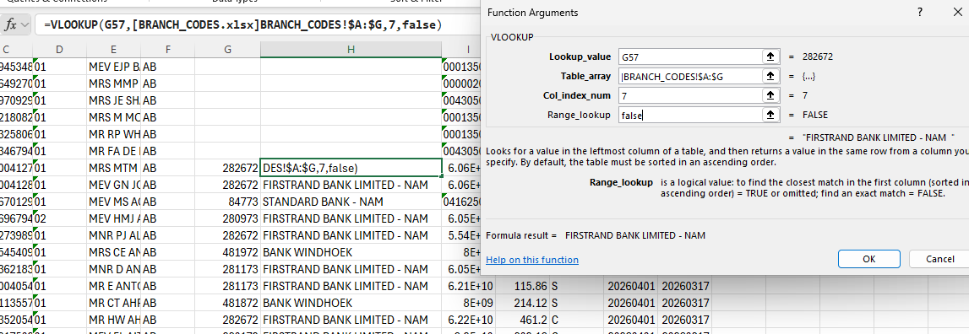
branch name will come
select branch name column Ctrl+c and paste value as 123
next step is to select column A to column J than insert Pivot table, new worksheet select.
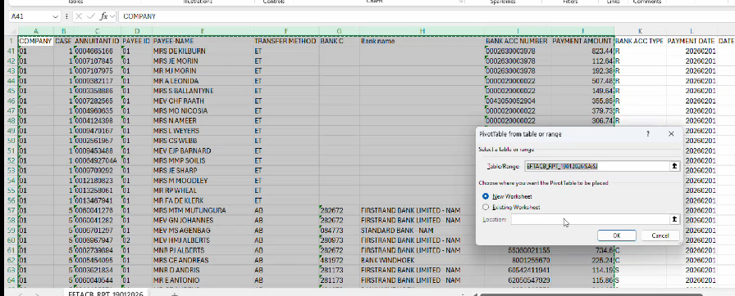

In row we want to select company and Case and in values select total payment amount.
and field for filter -> Transafer method and bank name/branch name
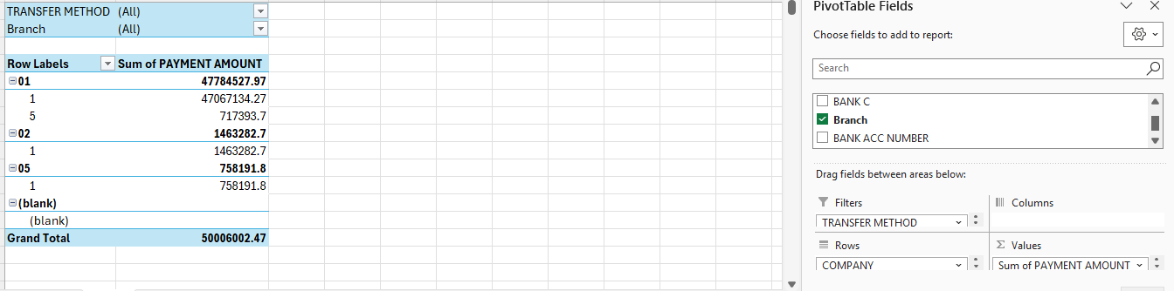

Now we can compare sum of payment amount with TOT file
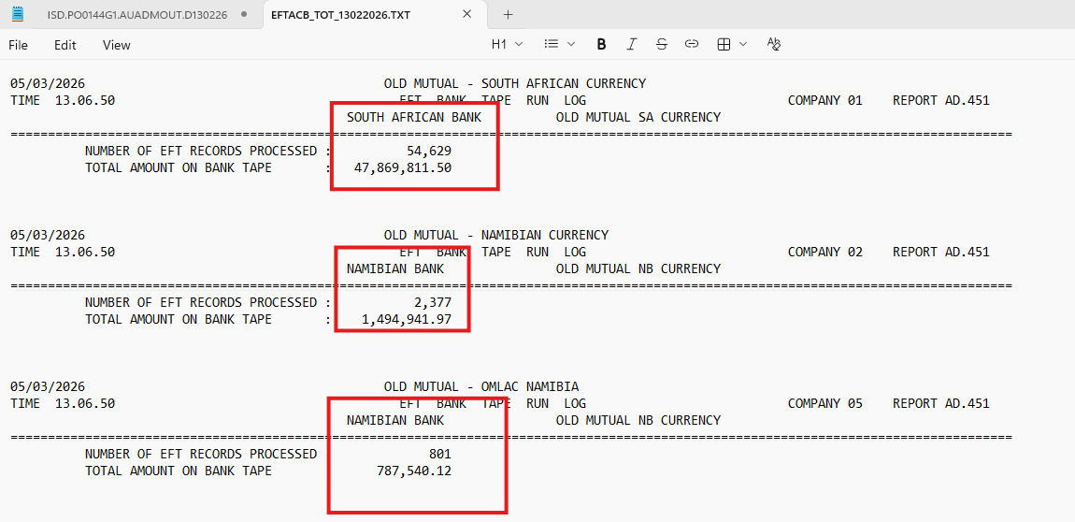
Now on sheet paste last month data
and filter on payment method AB now paste sum of payment amount to total payment. In column F, we are putting that so at end of activity we can compare values of column F and I must match.
now we need to select 4 NAM bank name
1 Bank of Windhoek
2. Firstrand bank limited -nam
3. Nedbank Namibia limited
4. Standard bank Namibia.
after selecting Nam bank account we will put all values in NAM bank account coulm.
now we need to select SA bank account name
Deselect the above 4 NAM bank names
after that put sum of payment amount in Column H
in column I total the values of column G and H it should be match with column F

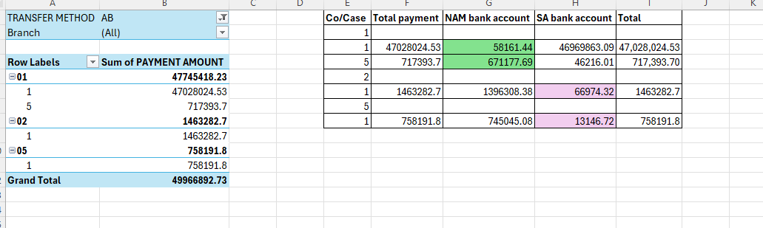
Co/Case | Total payment | NAM bank account | SA bank account | Total
1
1 | 47028024.53 | 58161.44 | 46969863.09 | 47,028,024.53
5 | 717393.7 | 671177.69 | 46216.01 | 717,393.70
2
1 | 1463282.7 | 1396308.38 | 66974.32 | 1463282.7
5
1 | 758191.8 | 745045.08 | 13146.72 | 758191.8
paste above table in Sheet shared by leigh in new tab and share with her.
We can perform this activity after bulk cycle or 1st working day of month or on request from Leigh. Below is the reference email

